
Software Design Description
On
Football Match Prediction using Machine Learning

Guided By: Dr. Upendra Verma
Prepared By: Pranav Kolhe (B228)
Abhraneel Das (B211)
Dhairya Desai (B212)
Date: ..............

Mukesh Patel School of Technology
Management and Engineering
Session: 2022-23

Certificate

The SDD Report entitled “Football Match Prediction using Machine Learning” being submitted by
“Pranav Kolhe” (Roll No.: B228)”
“Abhraneel Das” (Roll No.: B211)”
“Dhairya Desai” (Roll No.: B212)”

has been examined by us and is hereby approved for the award of degree “Bachelor of Technology in Computer Engineering Discipline”, for which it has been submitted. It is understood that by this approval the undersigned do not necessarily endorse or approve any statement made, opinion expressed or conclusion drawn therein, but approve the report only for the purpose for which it has been submitted.

(Internal Examiner) (External Examiner)
Date: Date:

DEPARTMENT OF COMPUTER ENGINEERING
Mukesh Patel School of Technology Management & Engineering

TABLE OF CONTENTS
1. INTRODUCTION
1.1 Purpose
1.2 Scope
1.3 Overview
1.4 Reference Material
1.5 Definitions and Acronyms
2. SYSTEM OVERVIEW
3. SYSTEM ARCHITECTURE
3.1 Architectural Design
3.2 Decomposition Description
4. DATA DESIGN
4.1 Data Description
4.2 Data Dictionary
5. OBJECT ORIENTED APPROACH
5.1 Use Case Diagram
5.2 Class Diagram
5.3 Activity Diagram
5.4 Sequence Diagram
5.5 Collaboration Diagram
5.6 State Chart Diagram
5.7 Component Diagram

1. INTRODUCTION
1.1 Purpose
This is a Software Design Description for the project Football Match Prediction Using Machine Learning. The purpose of our project is to successfully create a computer model that can successfully predict whether a football team would win, lose, or draw a match. By observing patterns, asking questions, and building a model, we will have a chance to push state-of-the-art technology farther.
The document is intended for sports analysts and researchers. It is also intended for football club managers and staff members. This project is a prototype model for football match prediction. It will be very useful for these individuals and will assist them by saving their time by predicting the match results and adjusting their strategy accordingly.

1.2 Scope
- Preparing a perfect strategy for their own team in a important and also a tedious task in sports industry. This also involves predicting and analysing every possible scenario of the future matches.
- May researchers have attempted to predict football match outcome using the in-game match statistics.
- There is so much data available other than that. Hence, creating a computer model that can predict the outcome of a particular football match would be of a great help.
- Predicting the outcomes of a match can help the analysts of a football team simulate a few strategies and pick the best ones for each match.
1.3 Overview
The aim of this document is to provide an overall software design description of the project Football Match Prediction using Machine Learning. Starting off with the Introduction of the project, the reader understands the purpose and the scope of the project. Also, if needed, the reader can check the references for more information on the topic. Shortforms that might not be known to the audience are also mentioned.
Moving on to the next part, a general description of the functionality, context, and design of the project is provided. The reader can go through it to understand the procedure that is to be followed throughout the process. First the system diagram is provided, that contains Architectural Design and Decomposition description. Next, we have data design. Finally, the description of data is provided through data description and dictionary.
The SDD ends with Object-Oriented Approach towards the project and Human Interface Design. The Object-Oriented Approach has 8 diagrams: Use Case Diagram, Class Diagram, Activity Diagram, Sequence Diagram, Collaboration Diagram, State Chart Diagram, Component Diagram and Deployment Diagram.
1.4 Reference Material
- [1] J. Almulla and T. Alam, “Machine Learning Models Reveal Key Performance Metrics of Football Players to Win Matches in Qatar Stars League,” IEEE Access, vol. 8, pp. 213695–213705, 2020, doi: 10.1109/ACCESS.2020.3038601.
- [2] S. K. Nivetha, M. Geetha, R. C. Suganthe, R. M. Prabakaran, S. Madhuvanan, and A. M. Sameer, “A Deep Learning Framework for Football Match Prediction,” 2022 International Conference on Computer Communication and Informatics, ICCCI 2022, 2022, doi: 10.1109/ICCCI54379.2022.9740760.
- [3] S. Manish., V. Bhagat, and R. M. Pramila, “Prediction of football players performance using machine learning and deep learning algorithms,” 2021 2nd International Conference for Emerging Technology, INCET 2021, May 2021, doi: 10.1109/INCET51464.2021.9456424.
- [4] A. A. Azeman, A. Mustapha, N. Razali, A. Nanthaamomphong, and M. H. Abd Wahab, “Prediction of football matches results: Decision forest against neural networks,” ECTI-CON 2021 - 2021 18th International Conference on Electrical Engineering/Electronics, Computer, Telecommunications and Information Technology: Smart Electrical System and Technology, Proceedings, pp. 1032–1035, May 2021, doi: 10.1109/ECTI-CON51831.2021.9454789.
- [5] D. Wang, “Clustering and Evolutionary System Analysis of Data Mining Algorithms in the Field of Football,” 2022 IEEE Asia-Pacific Conference on Image Processing, Electronics and Computers, IPEC 2022, pp. 1341–1344, 2022, doi: 10.1109/IPEC54454.2022.9777487.
- [6] S. N. Maozad, S. Noor Asyikin Mohd Razali, A. Mustapha, A. Nanthaamornphong, M. H. Abdul Wahab, and N. Razali, “Comparative Analysis for Predicting Football Match Outcomes based on Poisson Models,” pp. 1–4, Jun. 2022, doi: 10.1109/ECTI-CON54298.2022.9795385.
- [7] Rahman, M.A. A deep learning framework for football match prediction. SN Appl. Sci. 2, 165 (2020). https://doi.org/10.1007/s42452-019-1821-5
- [8] N. Danisik, P. Lacko and M. Farkas, "Football Match Prediction Using Players Attributes," 2018 World Symposium on Digital Intelligence for Systems and Machines (DISA), 2018, pp. 201-206, doi: 10.1109/DISA.2018.8490613.
- [9] Qiyun Zhang, Xuyun Zhang, Hongsheng Hu, Caizhong Li, Yinping Lin, Rui Ma, Sports match prediction model for training and exercise using attention-based LSTM network, Digital Communications and Networks, Volume 8, Issue 4, 2022, Pages 508-515, ISSN 2352-8648, https://doi.org/10.1016/j.dcan.2021.08.008.
- [10] N. Z. S. T. P. S. U. S. L. K. T., “Prediction of Football Match Score and Decision-Making Process”, IJRITCC, vol. 6, no. 2, pp. 162–165, Feb. 2018.v[11]
- [11] Hervert-Escobar, L., Hernandez-Gress, N., Matis, T.I. (2018). Bayesian Based Approach Learning for Outcome Prediction of Soccer Matches. In: , et al. Computational Science – ICCS 2018. ICCS 2018. Lecture Notes in Computer Science(), vol 10862. Springer, Cham. https://doi.org/10.1007/978-3-319-93713-7_22
- [12] Rahman, Muhammad & Mustapha, Aida & Fauzi, Rahmat & Razali, Nazim. (2018). Bayesian Approach to Classification of Football Match Outcome. International Journal of Integrated Engineering. 10. 10.30880/ijie.2018.10.06.022.
- [13] E. Tiwari, P. Sardar and S. Jain, "Football Match Result Prediction Using Neural Networks and Deep Learning," 2020 8th International Conference on Reliability, Infocom Technologies and Optimization (Trends and Future Directions) (ICRITO), 2020, pp. 229-231, doi: 10.1109/ICRITO48877.2020.9197811.
- [14] L. Hervert-Escobar, T. I. Matis and N. Hernandez-Gress, "Prediction Learning Model for Soccer Matches Outcomes," 2018 Seventeenth Mexican International Conference on Artificial Intelligence (MICAI), 2018, pp. 63-69, doi: 10.1109/MICAI46078.2018.00018.
- [15] Fátima Rodrigues, Ângelo Pinto, Prediction of football match results with Machine Learning, Procedia Computer Science, Volume 204, 2022, Pages 463-470, ISSN 1877-0509, https://doi.org/10.1016/j.procs.2022.08.057.
- [16] T. Korotyeyeva, R. Tushnytskyy and V. Kulyk, "Applying Neural Networks to Football Matches Results Forecasting," 2018 IEEE 13th International Scientific and Technical Conference on Computer Sciences and Information Technologies (CSIT), 2018, pp. 278-282, doi: 10.1109/STC-CSIT.2018.8526756.

1.5 Definitions and Acronyms
- SDD – Software Design Description
- ML – Machine Learning
- NB – Naïve Bayes
- TAN – Tree Augmented Naïve Bayes
- GAN – General Augmented Naïve Bayes
- KNN – K-Nearest Neighbour
- MLP – Multi-layer Perceptron
- SVM – Support Vector Machine
- FKM – Fuzzy K-Means
- LSTM – Long Short-Term Memory

2. SYSTEM OVERVIEW
One of the most popular sports in the world is Football. Millions of people watch Football every day. Big clubs like Manchester City, Barcelona, Real Madrid, etc. have a huge fan following. With such a huge fan following comes huge expectations. Every fan wants its team to win.
This makes the Predictions of Football matches even more popular, be it the manager, staff, pundits or even the fans themselves. Football is one of the most far reaching and famous game, along these lines anticipating the consequences of a football match represents a fascinating test. Forecast can likewise help administrators and clubs in settling on the best choices to win associations and competitions. In view of the huge financial stakes engaged with wagering, there is an interest for high prescient exactness in this industry.
In recent times, a lot of Research is been done in Football Predictions. Many Machine Learning and Deep Learning Algorithms are used to predict which team is going to win the match. It is been estimated that Football is played over 200 countries and 1.4 billion Football fans are supporting their teams globally. European Football alone exceeds 28 billion EUROS market scale. This forces the football team management to select proper strategy for each match. This is done with a team of analysts analyzing the data of their players, as well as their opponents.
Manual evaluation tends to generate many errors and take more time. In the current research the statistical model is proposed to predict the stats of the football player based on previous session data by considering various aspects of the game.
Our objective is to predict the outcomes of a Football match. We plan to use and compare multiple Machine Learning models, to find out which of the above models used can accurately predict the result of the match. We are going to use various parameters from the dataset to improve the accuracy of the model.

3. SYSTEM ARCHITECTURE
3.1 Architectural Design
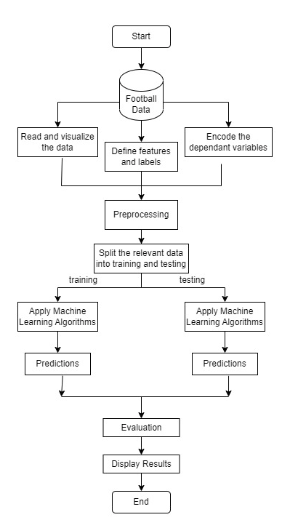

3.2 Decomposition Description
LEVEL – 0

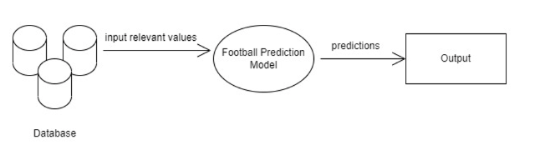

LEVEL – 1

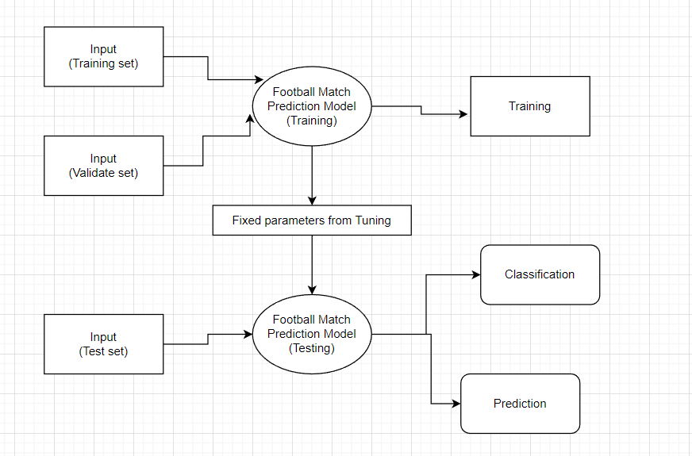

LEVEL – 2

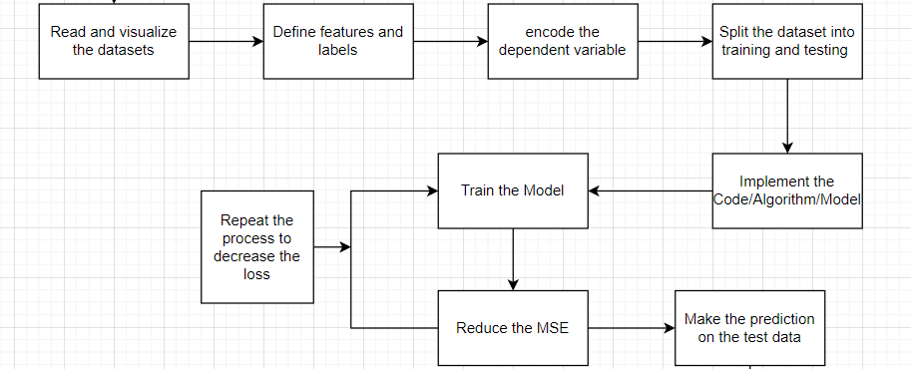

4. DATA DESIGN
4.1 Data Description
10 datasets are chosen by us to perform this project. Each dataset had the in-depth details and information of each match played in a particular season for the last ten years in English Premier League.
All the datasets have the same number of columns, i.e., 62 and 380 rows, each depicting one match played between two teams.
4.2 Data Dictionary
Each dataset has the same attributes. Main attributes are:
Div: - It provides the division of the team
Date: - It gives the date where the match takes place
HomeTeam: - Home team name
FTHG: - Full Time Home Goals
FTAG: - Full Time Away Goals
FTR: - Full Time Result
HTHG: - Half Time Home Goals
HTAG: - Half Time Away Goals
HTR: - Half Time Result
Referee: - Name of the referee
HS: - Home Shots
AS: - Away Shots
HST: - Home Shots on target
AST: - Away Shots on target
HF: - Home Fouls
AF: - Away Fouls
HC: - Home Corners
AC: - Away Corners
HY: - Home Yellow Cards
AY: - Away Yellow Cards
HR: - Home Red Cards
AR: - Away Red Cards

5. OBJECT ORIENTED APPROACH
5.1 Use Case Diagram
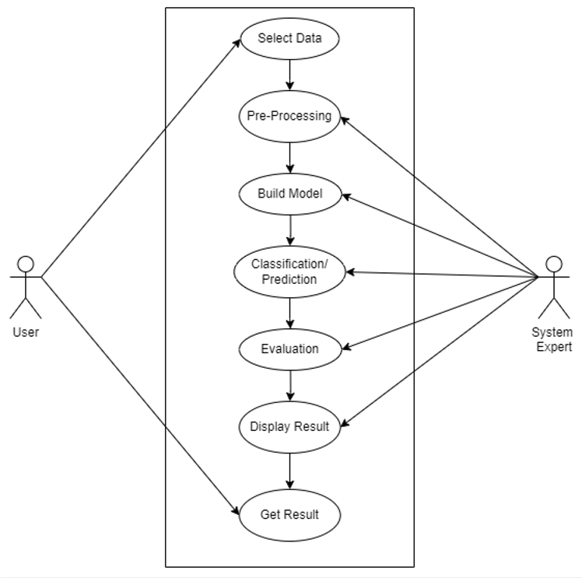

5.2 Class Diagram
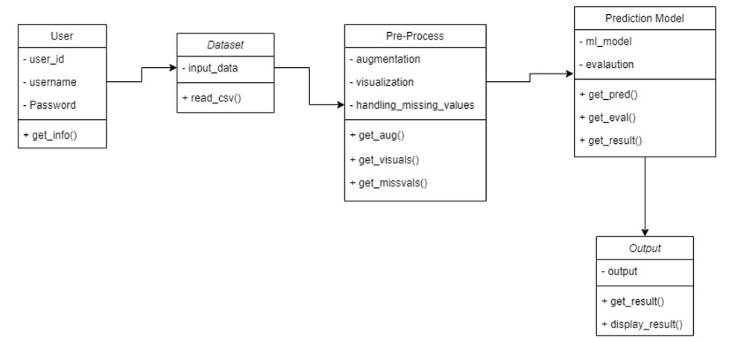
5.3 Activity Diagram

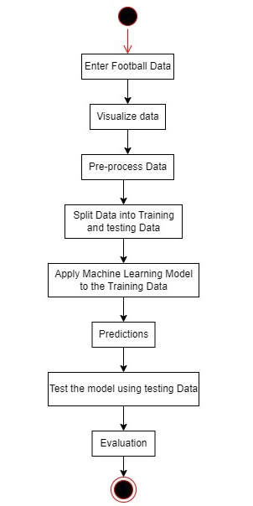

5.4 Sequence Diagram

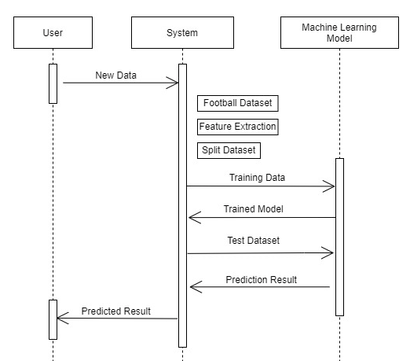

5.5 Collaboration Diagram
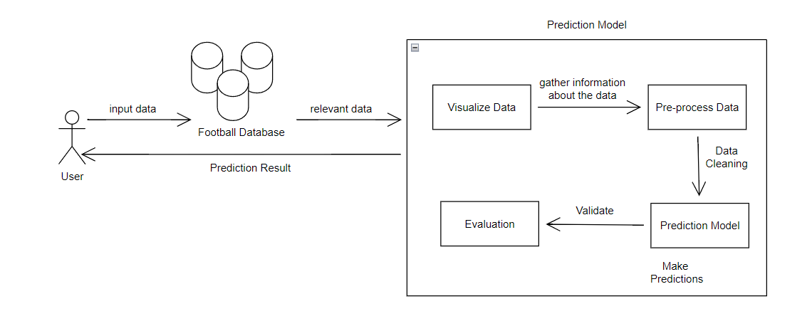
5.6 State Chart Diagram
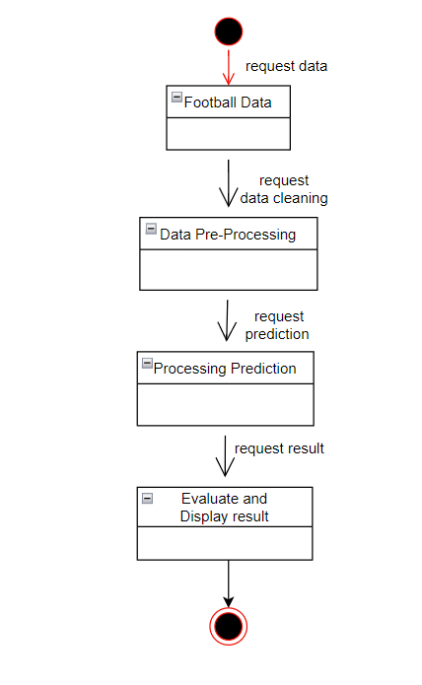
5.7 Component Diagram
